Step-1:

Enable POP/IAMP

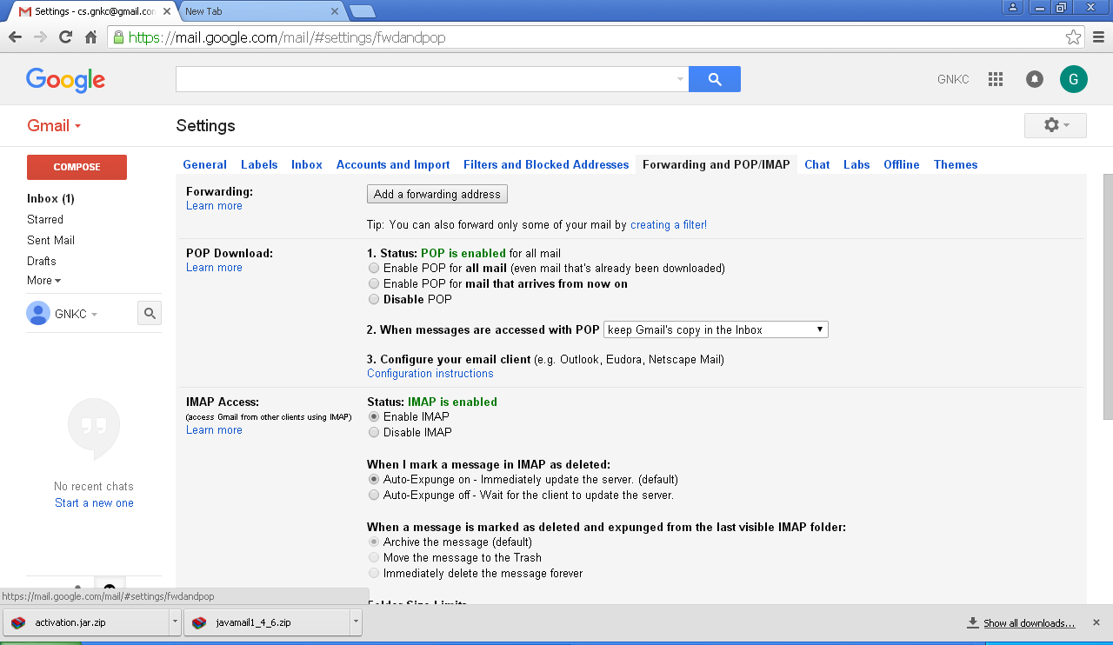

Step-2

Access to Less secure app: Turn On

https://www.google.com/settings/security/lesssecureapps

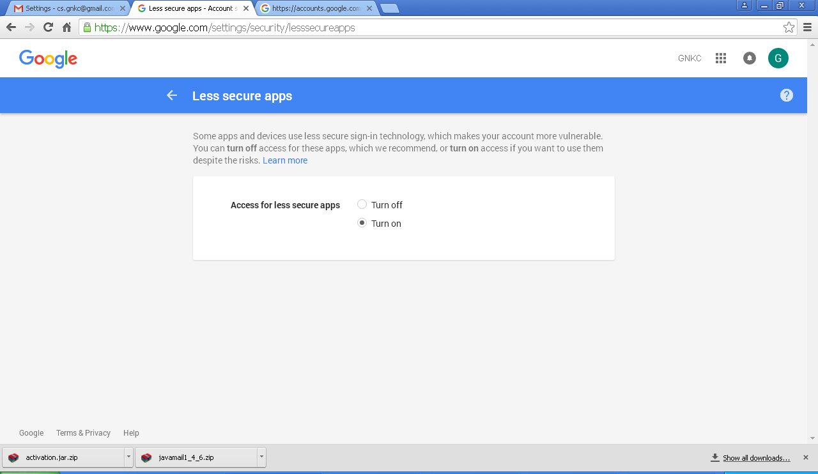

Step-3

https://accounts.google.com/DisplayUnlockCaptcha

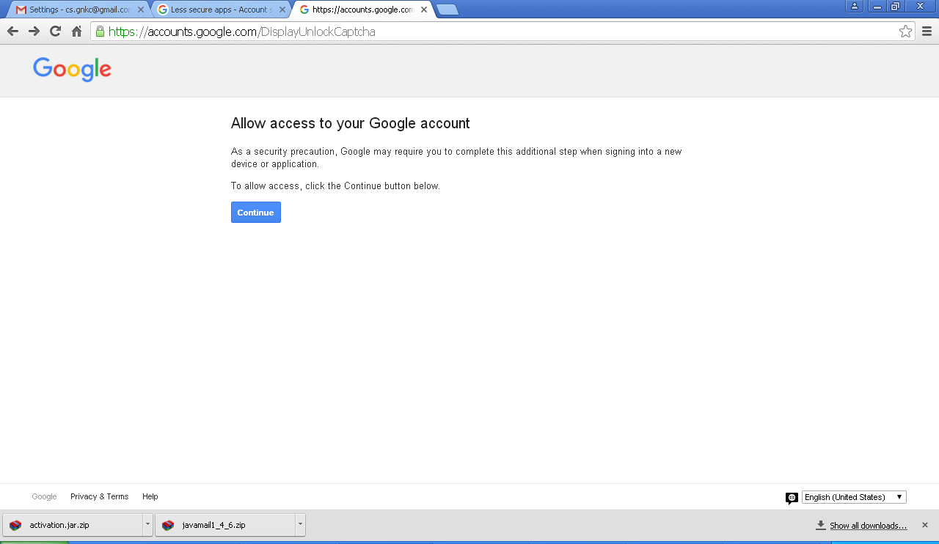

Gmail Forum:

<https://support.google.com/accounts/answer/6010255>

Source code:

/*

* To change this template, choose Tools | Templates

* and open the template in the editor.

*/

/**

*

* @author admin

*/

Import java.security.InvalidKeyException;

Import java.security.NoSuchAlgorithmException;

importjava.util.Properties;

importjavax.crypto.BadPaddingException;

import javax.crypto.Cipher;

import javax.crypto.IllegalBlockSizeException;

import javax.crypto.KeyGenerator;

import javax.crypto.NoSuchPaddingException;

import javax.crypto.SecretKey;

import javax.mail.Message;

importjavax.mail.MessagingException;

importjavax.mail.PasswordAuthentication;

import javax.mail.Session;

import javax.mail.Transport;

import javax.mail.internet.InternetAddress;

import javax.mail.internet.MimeMessage;

import sun.misc.BASE64Encoder;

public class Prac5

{

public static void main(String[] args)

{

Properties props = new Properties();

props.put("mail.smtp.starttls.enable", "true");

props.put("mail.smtp.host", "smtp.gmail.com");

props.put("mail.smtp.socketFactory.port", "587");

props.put("mail.smtp.socketFactory.class",

"javax.net.ssl.SSLSocketFactory");

props.put("mail.smtp.auth", "true");

props.put("mail.smtp.port", "587");

Session session = Session.getDefaultInstance(props,

newjavax.mail.Authenticator() {

protectedPasswordAuthenticationgetPasswordAuthentication()

{

return new PasswordAuthentication("msccs124@gmail.com","Viva123456");

}

});

try

{

String msg="hello all!!!",cipherText,decryptedText;

KeyGeneratorkeyGen = KeyGenerator.getInstance("AES");

keyGen.init(128);

SecretKeysecretKey = keyGen.generateKey();

Cipher aesCipher = Cipher.getInstance("AES");

aesCipher.init(Cipher.ENCRYPT_MODE,secretKey);

byte[] byteDataToEncrypt = msg.getBytes();

byte[] byteCipherText = aesCipher.doFinal(byteDataToEncrypt);

cipherText = new BASE64Encoder().encode(byteCipherText);

Message message = new MimeMessage(session);

message.setFrom(new InternetAddress("testmailid@gmail.com"));

message.setRecipients(Message.RecipientType.TO,

InternetAddress.parse("receivermailid@gmail.com"));

message.setSubject("Testing Mail....");

message.setText(cipherText);

Transport.send(message);

System.out.println("Your mail has been sent!!!");

}

catch (Exception e)

{

System.out.println(e);

}

}

}